**AW2b Inferring the population kurtosis value from the sample**

Your data set is just one sample drawn from a population. How far must the excess kurtosis be from 0, before you can say that the population also has non-zero excess kurtosis? The question is similar the question about skewness, and the answers are similar too. We advise that it is not possible to fully appreciate this section without reading Chapter 6. Accordingly, we recommend that you return to it after you have completed Chapter 6.

To assess the length of the tails and how peaked the distribution is we can calculate a measure of kurtosis and Excel and SPSS provide **Fisher’s kurtosis coefficient** as defined by equation (1).

$Sample kurtosis= \frac{n\left(n+1\right)}{\left(n-1\right)\left(n-2\right)\left(n-3\right)} \frac{\sum_{i=1}^{n}{{\left(x-\overline{x}\right)}^{4}}}{s^{4}}- \frac{3 {\left(n-1\right)}^{2}}{\left(n-2\right)\left(n-3\right)}$ (1)

where s represents the sample standard deviation.

The solution to our question is to divide the sample excess kurtosis by the standard error of kurtosis (SEK) to get the test statistic. This tells us how many standard errors the sample excess kurtosis is from zero as illustrated in equation (2)

$Z= \frac{Sample kurtosis}{Standard error of kurtosis}$ (2)

Where

$\text{Standard error}\text{ of kurtosis}\text{= }\sqrt{\frac{\text{24 n }{\left(n-1\right)}^{2}}{\left(n-3\right)\left(\text{n-2}\right)\left(\text{n+2}\right)\left(\text{n+5}\right)}}$ (3)

If the sample size, n, is large then equation (3) can be approximated by $\sqrt{{24}/n}$.

Don’t worry about this for now – it will become clearer when you have worked through Chapters 5, 6, 7 and 8. What we are undertaking here is to conduct a hypothesis test where the stated null and alternative hypotheses are:

**Hypothesis test**

Null hypothesis: Population kurtosis = 0 (distribution symmetric)

Alternative hypothesis: Population kurtosis ≠ 0 (distribution asymmetric)

The alternative hypothesis suggests a two-tail test and if we test at 95% then the value of the normal z statistic equals ± 1.96 which is approximately ± 2.

**Interpretation:**

The reference standard is a normal distribution, which has a kurtosis of 3. In token of this, often the excess kurtosis is presented: excess kurtosis is simply kurtosis − 3.

* A normal distribution has kurtosis exactly 3 (excess kurtosis exactly 0). Any distribution with kurtosis ≈3 (excess ≈0) is called **mesokurtic**.
* A distribution with kurtosis <3 (excess kurtosis <0) is called **platykurtic**. Compared to a normal distribution, its central peak is lower and broader, and its tails are shorter and thinner.
* A distribution with kurtosis >3 (excess kurtosis >0) is called **leptokurtic**. Compared to a normal distribution, its central peak is higher and sharper, and its tails are longer and fatter.

The critical value of Z is approximately 2. (This is a two-tailed test of excess kurtosis ≠ 0 at approximately the 0.05 significance level.)

* If Z < −2, the population very likely has negative excess kurtosis (kurtosis <3, platykurtic), though you don’t know how much.
* If Z is between −2 and +2, you can’t reach any conclusion about the kurtosis: excess kurtosis might be positive, negative, or zero.
* If Z > +2, the population very likely has positive excess kurtosis (kurtosis >3, leptokurtic), though you don’t know how much.

**Example**

Consider the student results obtained in a quantitative methods examination as presented in Table 1).

|  |  |  |  |  |  |  |  |  |  |
| --- | --- | --- | --- | --- | --- | --- | --- | --- | --- |
| 73 | 73 | 73 | 73 | 73 | 73 | 73 | 73 | 73 | 73 |
| 78 | 78 | 78 | 78 | 78 | 78 | 78 | 78 | 78 | 78 |
| 75 | 75 | 75 | 75 | 75 | 75 | 75 | 75 | 75 | 75 |
| 75 | 75 | 75 | 75 | 75 | 75 | 75 | 75 | 75 | 75 |

Table 1

Figures 1 illustrates the Excel solution for the first 10 data values with Figure W3.7 the calculation for the summary statistics (skewness, kurtosis).

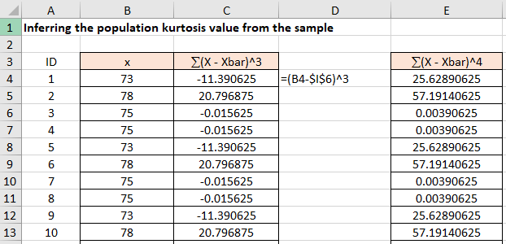

Figure 1

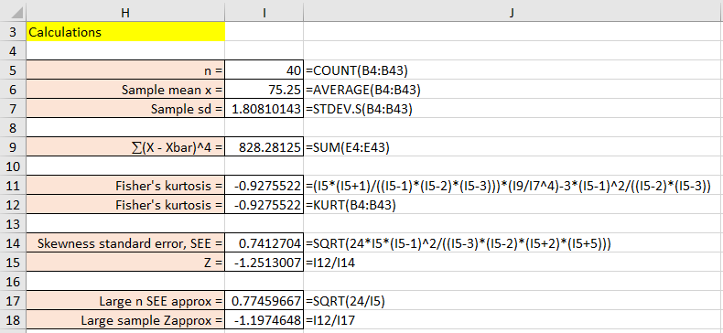

Figure 2

Since Z lies between −2 and + 2, you can say that the distribution is mesokurtic, normal distribution shape. But be careful: you know that it is mesokurtic, but you don’t know by how much.